Design DB model for Guvi Zen class Student Collection Batch Collection Task Collection Mentor Collection

Guvi Zen Class – DB Model

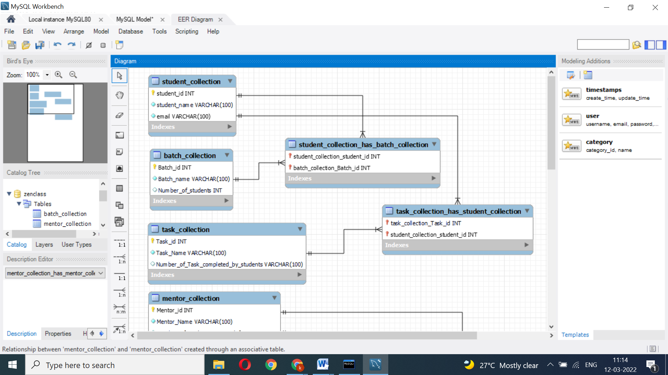

Student Collection

|  |  |  |
| --- | --- | --- |
| Student_id | Student_Name | email |
| 1 | Sakthi | [Sakthi123@gmail.com](mailto:Sakthi123@gmail.com) |
| 2 | Kaaviya | [Kaaviya123@gmail.com](mailto:Kaaviya123@gmail.com) |
| 3 | Veni | [Veni123@gmail.com](mailto:Veni123@gmail.com) |

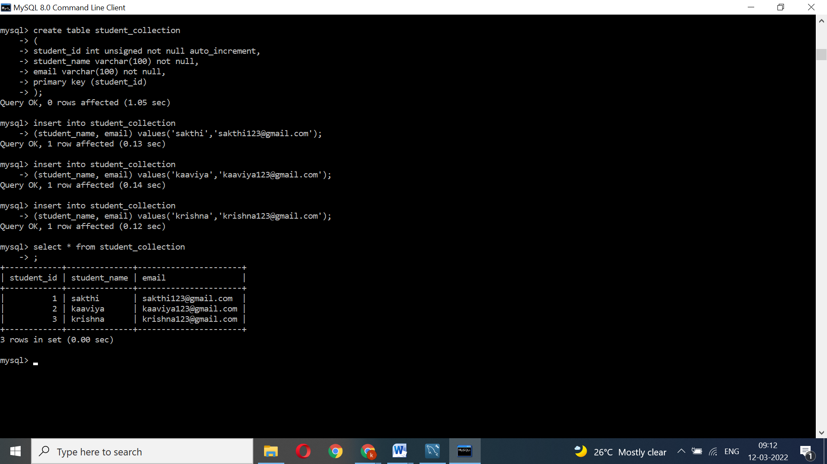

Batch Collection

|  |  |  |
| --- | --- | --- |
| Batch_id | Batch_Name | Number of students |
| 1 | B30WD tamil | 60 |
| 2 | B31WD tamil | 55 |
| 3 | B32WD tamil | 61 |

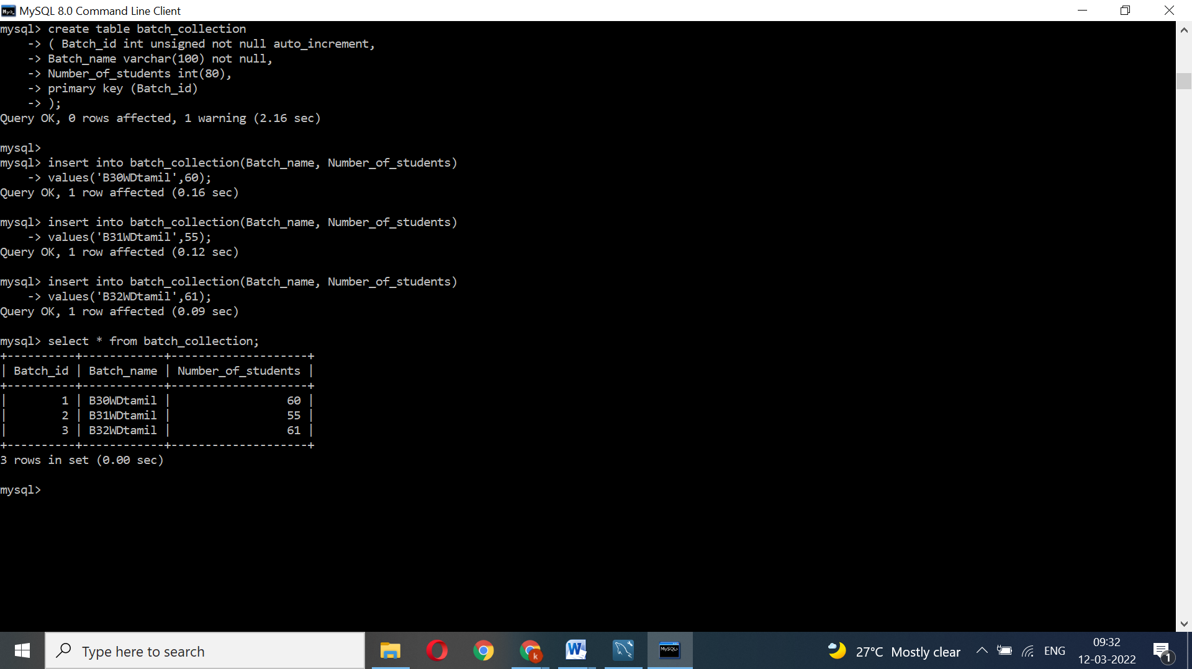

Task Collection

|  |  |  |
| --- | --- | --- |
| Task_id | Task_Name | Number of Task completed by students |
| 1 | Task_1 | 65 students completed |
| 2 | Task_2 | 53 students completed |
| 3 | Task_3 | 50 students completed |

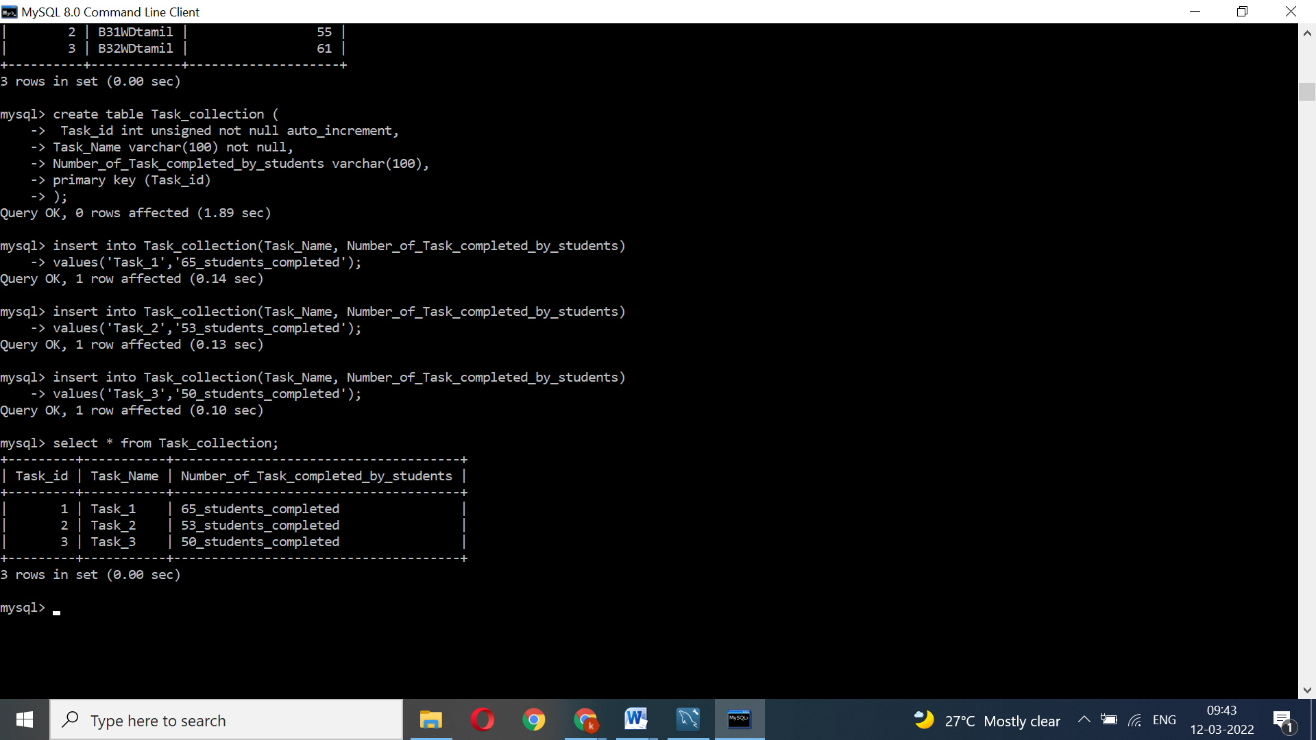

Mentor Collection

|  |  |  |
| --- | --- | --- |
| Mentor_id | Mentor_Name | Number of students Assigned for Mentor |
| 1 | Mentor_1 | 40 |
| 2 | Mentor _2 | 45 |
| 3 | Mentor _3 | 43 |

